**UNIVERSITY OF DAR ES SALAAM**

**COLLEGE OF INFORMATION AND COMMUNICATION TECHNOLOGIES**

**PROJECT TITLE**: MUNICIPAL CLEANING MANAGEMENT MOBILE BASED SYSTEM

# 

# DECLARATION

We hereby declare that this project progressive report is a work of our own hands that we wrote ourselves with the help of different materials, knowledge, information from ILALA municipality together with assistance from our mentors.

TABLE OF CONTENTS

DECLARATION i

LIST OF ABBREVIATIONS v

TABLE OF FIGURES vi

TABLE OF TABLES vii

CHAPTER ONE 1

1. INTRODUCTION 1

**1.1. General introduction** 1

**1.2. Problem statement** 2

**1.3. Objective** 2

**1.3.1. Main objective** 2

**1.3.2. Specific objectives** 2

**1.4. Significance of the project** 2

**1.5. Project scope** 3

**1.6. Organization of report** 4

CHAPTER TWO 5

2. LITERATURE REVIEW 5

**2.1. Introduction** 5

**2.2. Related work** 5

**2.2.1. municipal cleaning service** 5

**2.3. Project gap** 6

CHAPTER THREE 7

3. METHODOLOGY 7

**3.1. Introduction** 7

**3.2. Iterative model** 7

**3.2.1 Planning** 8

**3.2.2 Analysis & design** 8

**3.2.3 Implementation** 8

**3.2.4 Testing** 8

**3.2.5 Deployment** 9

**3.2.6 Evaluation** 9

CHAPTER 4 10

4.0. SYSTEM ANALYSIS AND DESIGN 10

**4.1. Requirement gathering** 10

**4.1.1. Data collection** 10

**4.2. Requirement and system analysis** 11

**4.2.1. Functional Requirements** 11

**4.2.2. Non-functional requirement** 14

**4.3. Project scenario, actors and use case** 15

**4.3.1. Project scenario** 15

**4.3.2. Actors** 16

**4.3.2. Use case** 17

**4.3.3. Use case description** 18

**4.4. Database design** 21

**4.4.1. Data modeling** 21

**4.4.2. Relations from ERD** 23

REFERENCES 24

**APPENDICES** 25

**A1: questionnaire** 25

**A2: interview questions to municipal council (ilala municipality)** 25

**A3: Budget** 1

**A4: Schedule** 2

# LIST OF ABBREVIATIONS

**APP** APPPLICATION

**CD** CONTEXT DIAGRAM

**DFD** DATA FLOW DIAGRAM

**ERD** ENTITY RELATION DIAGRAM

**Xampp** CROSS-PLATFORM, APACHE, MYSQL, PHP, AND PERL

**VS-CODE** VSUAL STUDIO CODE

# TABLE OF FIGURES

Figure 1: Iteration model 7

Figure 2: Use case diagram 17

Figure 3: High level diagram 21

Figure 4: ERD 22

# TABLE OF TABLES

Table 1: Management of user 11

Table 2: management of Tasks 12

Table 3: Management of payments 12

Table 4: Management of report 13

Table 5: Management of schedule 13

Table 6: Non-functional requirements 14

Table 7: System Actors 16

Table 8: Use case description1 18

Table 9: Use case description2 19

Table 10: use case description 3 20

Table 11: Budget 1

Table 12: Schedule 2

# CHAPTER ONE

# 1.0. INTRODUCTION

## **1.1. General introduction**

Municipality refers to a town, or city that’s usually governed by mayor and council. This can be a corporate and political entity organized by residents of the area to operate within a prescribed geographic area for the purpose of providing public services. The state grants municipality the powers and authority that it exercises over its affairs. (encyclopedia britannica)

Municipality is not part of executive government but is autonomous authorities, elected directly by the people with a mandate to promote the development of their territory. They have extensive power to set up on their own projects and standards, provided they do not contravene national legislation. (merriam-webster) Municipal council functions include: -

* Provision of state-run home services and basic unmet needs such as health, education, environment cleanliness, drinking water in homes, recreation and sports.
* Organization and planning of the economic, social and environmental development of their territory and construction of facilities required for municipal progress.

Many municipal councils face growing demands for services amid shrinking revenue streams, such as resource scarcity and climate crisis, which present threats to urban residents and the infrastructure systems they depend on. One of the most visible manifestations of urban growth and infrastructure backlog is the presence of waste in cities; It is implicated in environmental pollution, disease, infrastructure damage, flooding, and for undermining the beauty of urban public space.

(interactbio.iclei.org)

However, this challenge can also be facilitated by various factors such as failing and delaying of municipal workers to work effectively on their cleaning services and duties such as cleaning of city areas and collection of garbage from the streets, homes, and marketplaces.

## **1.2. Problem statement**

Delaying and failing of municipal council cleaning workers to collect garbage and cleaning different areas on time. This leads to presence of unpleased environment due to random throwing of garbage to areas such as in or near by Ocean, Near roads, and in streets, From different fields such as home, Office, Industries, Hospital, Playgrounds, Schools, Colleges and from marketplaces.

## **1.3. Objective**

### **1.3.1. Main objective**

To develop a mobile application that will help keeping our environment clean, reducing cleanliness challenges, connecting people with municipal cleaning workers on time, enhancing reliable cleaning services and oversee service provider performance.

## **1.3.2. Specific objectives**

* To perform requirement gathering from targeted people, municipal cleaning workers and municipal council.
* Design and implement mobile application that people can use it in getting desired cleaning services on time from their municipality
* To test the mobile application to user and get feedback.

## **1.4. Significance of the project**

The project has various importance such as: -

* Helping in keep our environment clean by making required cleaning services to be performed on time and reliable.
* Providing awareness about the quality of cleaning services that user deserved.
* Helping municipality to get cleaning service feedbacks, views and reviews from the customer.
* Facilitating the increasing municipal income rate.

## **1.5. Project scope**

Building a municipal cleaning management mobile application that will provide resident with the ability to request and submit cleaning service tasks, viewing schedule, do online payment and getting notification when service provider arrives.

The APP should also allow service provider to view cleaning service task schedule and submitting their performance report together with allowing Municipality to view tasks submitted by resident, create task schedule for service provider and resident, and oversee the service provider performance by oversee the service provider performance report and track down the service provider location.

The APP will consist of several user interfaces such as: -

* Home interface page, login interface page, Resident interface page, e-wallet page, Service provider interface page, and Municipality interface page.

The APP will be built using flutter frame work for frontend and Laravel for backend. The development of such an exemplary solution would include the following capabilities: -

* Connection with MYSQL database.
* Resident Rating system.
* Notifications.
* Connection with e-wallet for online transaction.
* Scheduling of task by municipality and get viewed by service providers and.
* Requesting and submission of cleaning service task and their descriptions if any.
* Submission of Service provider report and approval of the report by Municipality.
* Tracking down of service provider’s location by Municipality.

## **1.6. Organization of report**

The report is organized to three chapters. Which are. -

CHAPTER ONE: This chapter is introducing the system by providing the background introduction, problem statement, objectives, significance, project scope,

CHAPTER TWO: This chapter is all about the literature review and other related works. It also shows the pictures of the existed systems or approaches.

CHAPTER THREE: This chapter covers the methodology to be used for the system, justifications of the used methodology and the phases to be followed.

CHAPTER FOUR: This chapter covers the system analysis and design including requirement gathering, data collection, functional and non-functional requirements, actors, usecase description and diagram together with database design.

# CHAPTER TWO

# 2.0. LITERATURE REVIEW

## **2.1. Introduction**

A literature review is a category of review article. A comprehensive survey on relevant article journals/articles that relate to the project is conduct which may help in the developing process of municipal cleaning management mobile based system. Essential details will be listed and described concisely. Some existing systems are compared to depict a clear picture and ideas to design a better system. The literature review helps enhance the understanding of the knowledge on the associated topic and identify the gaps of the existing system for improvement.

## **2.2. Related work**

### **2.2.1. Municipal cleaning service**

Municipalities perform cleaning services in cities through a combination of in-house staff and contractors. The specific process for performing cleaning services may vary from municipality to municipality, but for ILALA municipality a general outline of the process is as follows:

Planning: The municipality identifies the areas in the city that require cleaning, such as public parks, sidewalks, and streets. They also determine the resources required to perform the cleaning, including staffing, equipment, and supplies.

Scheduling: The municipality schedules the cleaning services based on the availability of the resources and the priority of the cleaning needs. The scheduling information is communicated to the cleaning crews and contractors, who are responsible for performing the cleaning services.

Dispatch: The cleaning crews and contractors are dispatched to the specified locations on the scheduled date and time to perform the cleaning services. The municipality provides the necessary equipment and supplies to the crews and contractors.

Cleaning: The cleaning crews and contractors perform the cleaning services, such as sweeping, power washing, and litter pick-up, in accordance with the municipality's guidelines and standards.

Inspection: The municipality inspects the cleaning services to ensure that they meet the required standards and quality. If necessary, additional cleaning services may be performed to correct any issues.

Reporting: The municipality tracks and reports on the cleaning services performed, including the type of service, location, and cost. The information is used to evaluate the performance of the cleaning services and make decisions on how to improve the service delivery.

## **2.3. Project gap**

The main challenge is delaying of cleaning services to people from the cleaning service providers and presence of informal payments to resident from service provider. Hence even the cleaning services are not sufficiently and efficiently provided. From different reviews the problem can be solved by integrate the system with online payment and allow municipality to oversee the performance of the service provider by digitally schedule tasks and inspect their performance reports.

**2.4. Proposed system**

The proposed system is MUNICIPAL CLEANING MANAGEMENT MOBILE BASED SYSTEM, that will help resident to request for the cleaning service and perform online payment. The system will also enable service providers to view their task schedule, and submit their performance report of the service provided to a specific resident or area. The system will also enable Municipality to view Resident’s tasks, create the schedule, view Service provider’s report, and track down Service provider location, so as to oversee the service provider performance and ensure that service providers are on time and provide the desired cleaning services.

# CHAPTER THREE

# 3.0. METHODOLOGY

## **3.1. Introduction**

This chapter included the technique and procedures for conducting a project. A methodology is used to develop a system. It defines the steps involved in the software development process. It is necessary to ensure that the implementation of the framework is achieved systematically and effectively. The proposed system, therefore, uses Iterative Methods as guidelines to develop it.

## **3.2. Iterative model**

The iterative model is the repetition incarnate of the processes. It applies the concept of incremental development which defines the incremental changes made during the design and implementation of each new iteration.

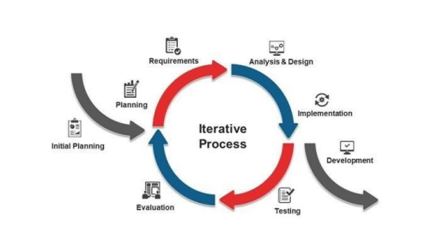

Figure 1: Iteration model

### **3.2.1 Planning**

Planning is the first phase of the iterative model. At this point, the project title was chosen: Municipal Cleaning management mobile based System. The problem statements of the system are identified. Meanwhile, the expected outcome would be regarded as achievable. Gantt chart will be needed as the guideline and references for the project. Besides, in this phase, project requirements needed to design and develop the system are specified. Based on the information gathered through articles, suitable method and technique for the system have been decided.

### **3.2.2 Analysis & design**

In this phase, every requirement identified is analyzed for more understanding. Diagrams constructed to show the flow of the system include Context Diagram (CD), Data Flow Diagram (DFD) Level 0 and 1, Entity Relationship Diagram (ERD).

### **3.2.3 Implementation**

Codes will be implemented in the real system during this phase based on the dataflow and data model. User interfaces are included in this phase to deliver information to the user following the Human-Computer interaction guidelines. Accordingly, the municipal cleaning management mobile based system will be develop using Xampp server for the database, Android Studio and visual code to code using dart as programming language and flutter as framework. Laravel language will be used to link the database and the APP using MySQL as the platform for the database. Collaborative Filtering method will be implemented to provide services booking suggestion to customers.

### **3.2.4 Testing**

After the implementation of the code, further testing will be carried out to test the smoothness of the system. Testing will be done to detect any defects that might lead to project failure and to ensure that the functionality of the system is running well. The system will be tested through unit testing, which used the white-box testing technique to test every module of the system. Then, system will go through the integration testing which used the black box testing to test the integrated modules. Thus, black box testing will simulate the end-user experience to book the service offered. The testing occurs throughout the software development and Testing Life Cycle of system to test the overall functionality.

### **3.2.5 Deployment**

This stage needs to get the project ready for the end-user to use the system practically after the bugs and defects spotted during the test phase are removed. User will use it to make sure the system is precisely well functioning or not. System should work well to ensure satisfactory results for the project.

### **3.2.6 Evaluation**

The final phase is the evaluation phase. The system that has encountered the deployment phase will be presented to the user. The user will evaluate the system, thus, all the feedback received gathered helps to improve the system. This phase will follow-up with the user to enhance the system to the better version in the future either in terms of features or functions of the system**.**

**3.3. Why iterative mode**

* Teams can quickly adapt to requirements changes without negatively impacting the release dates.
* Greater customer satisfaction.
* This model is suitable for identifying risks associated with the requirements early and mitigating them

# CHAPTER 4

# 4.0. SYSTEM ANALYSIS AND DESIGN

## **4.1. Requirement gathering**

Requirements gathering is the process of collecting and documenting the requirements for a particular project or product. The purpose of requirements gathering is to clearly understand and define what the stakeholders such as customers, users, and project team members expect from the project, so that it can be delivered successfully and delivered on time, within budget, and with the desired quality.

### **4.1.1. Data collection**

Data collection refers to the process of gathering information and data from various sources, including surveys, interviews, online sources, and observational studies. The aim of data collection is to gather information that is relevant and useful for a particular purpose or research project. The data collected can be qualitative or quantitative in nature, and can be analyzed using statistical methods to gain insights, draw conclusions, and make informed decisions.

Methods used in data collection includes: -

* Interview

It involves face to face or phone interaction between two or more people. Questions were prepared and asked to some of municipality officers and other community stakeholders like” mwenyekiti” based on how municipality manage and organizing environment cleaning services in general. Interviews were done at ILALA MUNICIPAL AND BANGULO (WARD).

* Questionnaire

Google form was created and supplied to users via a link

According to the research done, about 91.5% of the people are aware of the different cleaning services provided by municipality to their citizen through different cleaning service providers. But people are mostly facing different challenges on how cleaning services are provided from the service providers, this includes: -

* Delaying of cleaning services to people from the cleaning service providers.
* The cleaning services are not sufficiently and efficiently provided.

Through interviews from municipality (case study in ILALA), there are various challenges encounter municipality on the issue of providing cleaning services, this include: -

* Presence of informal cost charges to people over the cleaning services provided from the cleaning service providers.
* Delaying on provision of cleaning services to different areas since service providers are not on time.
* Delaying of information on the need of cleaning services and waste collection from different places.

## **4.2. Requirement and system analysis**

### **4.2.1. Functional Requirements**

|  |  |  |  |
| --- | --- | --- | --- |
| S/N | **FUNCTIONAL DISCRIPTION** | | **CATEGORY** |
| F1 | **Management of user** | | |
| 1.1 | System should allow Resident to register and log in by entering their phone number and password. | Evident | |
| 1.2 | System should allow Service provider to register and log in by entering phone number and password. | Evident | |
| 1.3 | The municipality should be able to register, login and manage users, including adding, editing, and deleting users as needed. | Evident | |

Table 1: Management of user

|  |  |  |  |
| --- | --- | --- | --- |
| S/N | **FUNCTIONAL DISCRIPTION** | | **CATEGORY** |
| F2 | **Management of Task** | | |
| 2.1 | The Municipality should be able to view and manage tasks, including setting priorities. | Evident | |
| 2.2 | Service providers should be able to view their assigned tasks and update task status. | Evident | |

Table 2: management of Tasks

|  |  |  |  |
| --- | --- | --- | --- |
| S/N | **FUNCTIONAL DISCRIPTION** | | **CATEGORY** |
| F3 | **Management of payments** | | |
| 3.1 | System should allow Resident to enter Phone number. | Evident | |
| 3.2 | System should generate control number for the resident and get it through SMS. | Evident | |
| 3.3 | System should allow user to get payment invoice. | Evident | |
| 3.4 | System should store transaction details | Hidden | |

Table 3: Management of payments

|  |  |  |  |
| --- | --- | --- | --- |
| S/N | **FUNCTIONAL DISCRIPTION** | | **CATEGORY** |
| F4 | **Management of report** | | |
| 4.1 | Service providers should be able to submit reports, including information on the tasks they completed. | Evident | |
| 4.2 | The municipality should be able to view and review reports and approving reports. | Evident | |

Table 4: Management of report

|  |  |  |  |
| --- | --- | --- | --- |
| S/N | **FUNCTIONAL DISCRIPTION** | | **CATEGORY** |
| F2 | **Management of schedule** | | |
| 2.1 | The municipality should be able to view schedules uploaded by the service provider. | Evident | |
| 2.2 | Service providers and residents should be able to Upload and view schedules respectively together with receiving notifications of any changes or updates. | Evident | |

Table 5: Management of schedule

### **4.2.2. Non-functional requirement**

|  |  |
| --- | --- |
| **Non-Functional Requirements** | **Description** |
| Performance | The system should be able to handle a large number of users and tasks and provide fast and reliable performance. It should be scalable to meet changing demands. |
| Security | The system should be secure, protecting sensitive information such as personal details and payment information. It should enforce access controls and authenticate users. |
| Usability | The system should be user-friendly, with an intuitive and easy-to-use interface that is accessible to users of all levels of technical ability. It should be accessible and usable on a variety of devices, including smartphones and desktop computers. |
| Reliability | The system should be reliable and consistently available, with a high degree of uptime and minimal downtime. |
| Maintainability | The system should be easy to maintain, with clear documentation and well-defined processes for making updates and fixing bugs. |
| Compatibility | The system should be compatible with a range of operating systems and hardware, allowing it to be used by a wide variety of users. |

Table 6: Non-functional requirements

## **4.3. Project scenario, actors and use case**

### **4.3.1. Project scenario**

Resident Login: Resident is required to log in to the system through a mobile app enter the physical address and the password. This allows resident to view cleaning service schedule, make requests for cleaning services, make online payments and rating the service provided. The requests are processed by the municipality and are added to the schedule for the service provider.

Service Provider Login: Service provider is also required log in to the system by entering the names and password. Service providers use the system to view their schedules, receive notifications about new tasks, and to report on the completion of cleaning service provided to a specific resident or area.

Schedule Creation: The municipality uses the system to create and manage the schedule for cleaning and maintenance services. The schedule is created based on the requests received from residents and the availability of service providers.

Task Completion: The service provider uses the system to view the schedule and to receive notifications about new tasks. Once a task is completed, the service provider reports on the completion of the task through the system, including details such as the resources used, the time taken to complete the task, and the quality of the service provided.

Reporting and Monitoring: The municipality uses the system to view the reports submitted by the service provider and to monitor the performance of the service provider. This includes monitoring the completion of tasks, the quality of the services provided, and the satisfaction of residents.

Payment Processing: The payment processing is integrated with the system and allows residents to make online payments for the services provided. The municipality is able to view the payment status for each task and to ensure that payments are received for all completed tasks.

### **4.3.2. Actors**

From the municipal cleaning management system, there are several actors that play a role in process. These actors include:

|  |  |  |
| --- | --- | --- |
| **S/N** | **Actor** | **Descriptions** |
|  | Municipality | The municipality is the local government entity that contracts with service providers to provide cleaning and maintenance services. The municipality sets the standards and expectations for the services provided and monitors the performance of service providers to ensure that they are meeting these standards. |
|  | Service provider | Service provider is company or organization that provide cleaning and maintenance services to the municipality. Service providers may use a combination of in-house staff and external resources to deliver their services. Service provider is responsible for the collection, transportation, and disposal of municipal waste, including household waste, commercial waste, and recyclables. |
|  | Resident | Resident is the individual who live in the municipality and use the public spaces that are maintained by service providers. Resident may provide feedback to the municipality and service providers on the quality of the services provided. |

Table 7: System Actors

### **4.3.2. Use case**

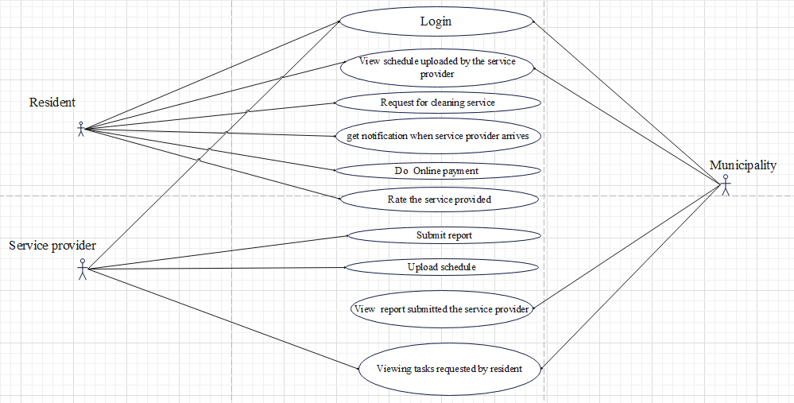

Figure 2: Use case diagram

### **4.3.3. Use case description**

|  |  |
| --- | --- |
| **USECASE NUMBER** | **1** |
| Use case name | Do online payment on the cleaning service provided |
| Actor | Resident |
| Description | The user will have to do online payment as the way to pay for cleaning service provided, so as to reduce presence of informal payments. |
| Pre-condition | * The user has to login to the system. * Enter phone number. * Get control number vi SMS |
| Post-condition | After payment, user will have to rate for the service provided. And get invoice. |
| Normal cause | * User will have to make online payment * Payment details should be stored |

Table 8: Use case description1

|  |  |
| --- | --- |
| **USECASE NUMBER** | **2** |
| Use case name | Submitting the cleaning service report of each resident. |
| Actor | Service provider |
| Description | Service providers will have to submit report of each resident on the cleaning tasks they have completed, including any issues that need to be addressed. |
| Pre-condition | * The service provider must have access to the municipal cleaning service system and have a valid login. |
| Post-condition | * The service provider will have to successfully submit the report for the cleaning tasks. * The report will be securely recorded in the system. * The municipality will have to access the report and will be able to review the details of the cleaning tasks |
| Normal cause | * The service provider will have to complete the cleaning service (task) required for specific resident or area as scheduled. * Service provider will have to submit the report. * The report details should be stored. |

Table 9: Use case description2

|  |  |
| --- | --- |
| **USECASE NUMBER** | **3** |
| Use case name | Monitor the performance of the service provider |
| Actor | Municipality |
| Description | The municipality will have to monitor the performance of service provider including the quality of the service provided and their punctuality. |
| Pre-condition | * The municipality has to log in. * The municipality has to view the tasks requested by residents. * The municipality will have to view the task schedule uploaded by the service provider. |
| Post-condition | * The municipality will have to view the report submitted by the service provider. |
| Normal cause | * The municipality will have to view the tasks requested by resident. * The municipality will have to view the task schedule for service providers. * The municipality will have to view the report submitted by service provider. |

Table 10: use case description 3

## **4.4. Database design**

### **4.4.1. Data modeling**

Data modeling is the process of creating a data model for an information system. The purpose of data modeling is to define the structure of data and the relationships between data elements in a way that supports the requirements of the information system. It involves identifying the data entities and their attributes, defining relationships between entities, and mapping the data into a database or other data storage system. model defines the actual implementation of the data in a database or other data storage system.

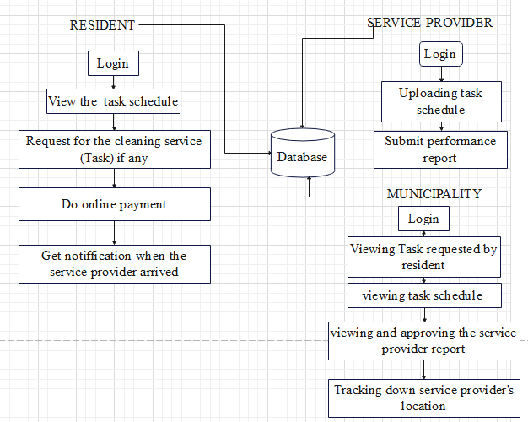

Figure 3: High level diagram

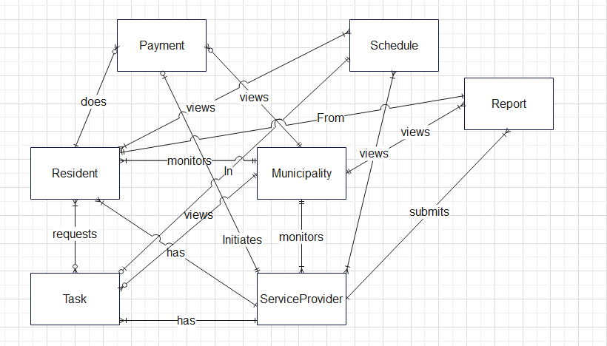

Figure 4: ERD

### **4.4.2. Relations from ERD**

**Resident** (ResidentId, ResidentName, PhysicalAddress, PhoneNumber, Email, PaymentStatus, MunicipalityId, ServiceProviderId)

**Municipality** (MunicipalityId, MunicipalityName, PhoneNumber, Email)

**ServiceProvider** (ServiceProviderId, ServiceProviderName, PhoneNumber, Email, Specialty, Location, MunicipalityId)

**Task** (TypeTask, Location, taskDescription, ServiceProviderId, MunicipalityId, ScheduleId)

**Schedule** (ScheduleId, DateOfScheduleUpDated, TimeOfScheduleUpDated, StatusOfTheSchedule, MunicipalityId)

**Payment** (PaymentId, AmountDue, PaymentMethod, PaymentStatus, ControlNumber, ResidentID, MunicipalityId, ServiceProviderId)

**Report** (ReportId, DateOfService, TimeOfService, TaskCompleted, QualityOfServiceProvided, Status, MunicipalityId, ServiceProviderId, ResidentId)

**RequestTask** (TaskId, ResidentId)

**ResidentViewScheduling** (ResidentId, ScheduleId)

**ServiceProviderViewScheduling** (ServiceProviderId, ScheduleId)

# CHAPTER 5

# 5.0. IMPLEMENTATION

This chapter will clearly represent the implementation of Municipal cleaning management system, taking into account of the objectives, functional requirement and non-functional requirements.

## **5.1. Technology Used**

This system is implemented using flutter framework and Laravel in front end and back end respectively.

### **5.1.1. Flutter**

Flutter is a mobile app development framework created by Google that allows developers to build natively compiled, fast and high-performance mobile applications for Android, iOS, and other platforms from a single codebase. Flutter uses a reactive programming model that enables developers to build custom UI components and animations quickly and easily, and it includes a rich set of pre-built widgets and tools that can be customized to fit specific design requirements. Flutter also has a hot-reload feature, which makes it easy for developers to experiment, build and iterate their apps quickly.

### **5.1.2. Laravel**

Laravel is a web application framework that is primarily used for building server-side web applications, and it is not designed specifically for building mobile applications. However, Laravel can be used in combination with other tools and frameworks to create the backend APIs and services required by a mobile app. For example, Laravel can be used to build a RESTful API that a mobile app can use to communicate with the backend server.

This allows developers to leverage Laravel's built-in features and tools to create a robust and secure backend for their mobile app. Additionally, Laravel has a community-driven package called "Laravel Passport" that provides a complete OAuth2 server implementation, allowing developers to easily add authentication and authorization to their mobile app.

### **5.1.3. Tools Used**

Tools that have contributed to the implementation and visualization of this System are: -

* **Visual studio code**- This is the code editor that allows the building of applications and web.
* **GitHub** - This is the revision control system that allows easy communication among the group members when implementing the project.
* **Android Studio**- Android Studio is the official Integrated Development Environment (IDE) for Android app development. It is developed by Google and based on the JetBrains IntelliJ IDEA software. Android Studio provides developers with a wide range of tools and features that are specifically designed to simplify the process of building, testing, and deploying Android apps.

## **5.2. User Interface**

User-interface (UI) is the point of human-interaction and communication in a device. This includes: display screens and appearance. It is the way through which a user interacts with an application or system. The user interface of the system is similar to all three types of users (Resident, Service provider and Municipality) except in their roles.

### **5.2.1. Home Page**

A home page is the main or introductory page of this System that serves as a gateway to the other pages of the APP. It is typically the first page that users see when they visit an APP and it sets the tone for the overall user experience. This user interface includes the name of the system, welcoming message, cleaning image and 3 cards hold Resident, Service provider and Municipality roles respectively.

### **5.2.2. Login & Registering Page**

login page typically consists of a card having a form with fields for the user to enter their email address and their password. The login page also consists options for users to reset their password, remember me option, and register now. Once the user enters their login credentials, the app verifies their identity and grants access to the app's features and data.

A registering page, also known as a sign-up page, is where new users create an account for the mobile app. The registration page typically consists of a form where the user enters their personal information, such as their name, email address, a password, Municipality name, phone number and Physical Address. Once the user saves and submits the registration form, the app creates a new account for the user and stores their information securely. After the registration process is complete, the user can then log in to the app using their newly created account. The pages are the same to all user despite the difference in their credentials.

### **5.2.3. Resident Page**

The purpose of a resident page is to provide relevant cleaning information and services to residents, and to facilitate communication between residents and Municipality. Resident page includes information of accessing forms for requesting cleaning tasks or reporting cleanliness issues in task request Page. It also includes features for payment in Payment Page and option of viewing schedule.

### **5.2.4. Service provider Page**

The page consists of a form where the service provider has to create report for the cleaning task performed and submit. Also, service provider Page has option for the service provider to view schedule.

### **5.2.5. Municipality Page**

The page allow municipality to manage service provider (adding, deleting, and editing Service provider), uploading schedule and viewing Resident submitted requested task, and viewing report submitted by Service provider.

## **5.3. Database Implementation**

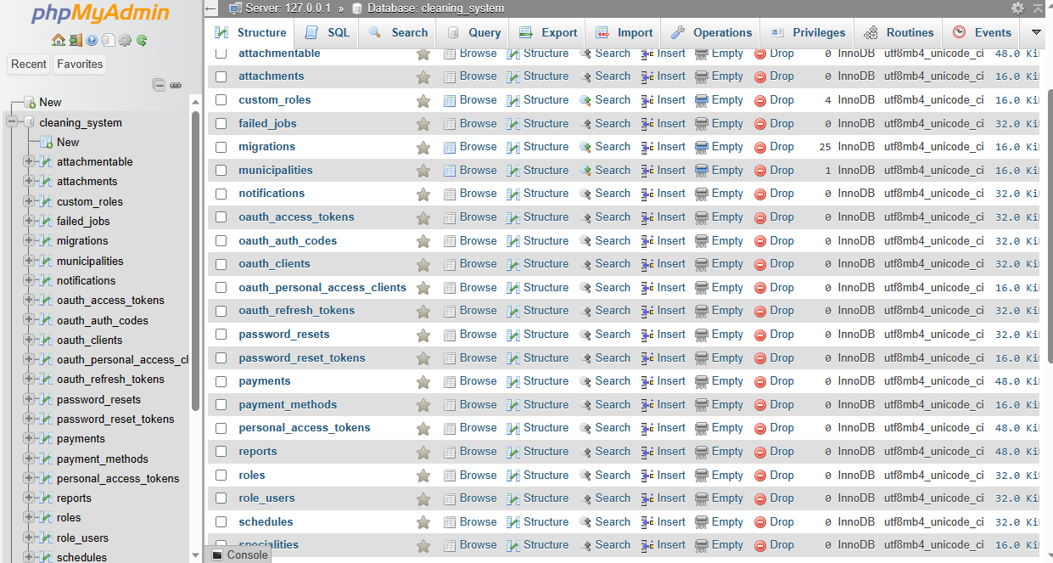

# REFERENCES

Allen. (1993).

*encyclopedia britannica.* (n.d.). Retrieved from encyclopedia britannica: https:// www.encyclopedia britannica.com

*interactbio.iclei.org.* (n.d.). Retrieved from interactbio.iclei.org: https:// interactbio.iclei.org

Johnston. (1995).

Kyengo. (2007).

*merriam-webster.* (n.d.). Retrieved from merriam-webster: https:// www.merriam-webster.com

Stephens. (1997).

## 

## **APPENDICES**

## **A1: Questionnaire**

* Have you ever experienced presence of waste in your area, street, or in your working place?
* How do you dispose your waste?
* How do you manage your environmental cleanliness services around your areas?
* How are collection of waste and other cleaning services performed by your ward or municipality in your area?
* Do you know that, there are municipal cleaners (service providers) who collect waste and involve in performing various environmental cleaning services?
* Have you ever had cleaning services tasks done by municipality (service providers) including waste collection and other environmental cleaning services?
* Was the service provided sufficiently detailed for your needs?
* How did you pay them?
* Did the cleaners on time?
* In general, have municipal cleaning services found to be helpful in your city?

## **A2: Interview questions to municipal council (ilala municipality)**

* Do ILALA municipality has municipal cleaning workers?
* How do they work?
* How do you pay them?
* How do you know if there are places need cleaning services?
* How do you reach citizen on the issue of environment cleanliness?
* How environmental cleanliness services including waste collection are done or provided in ILALA MUNICIPALITY